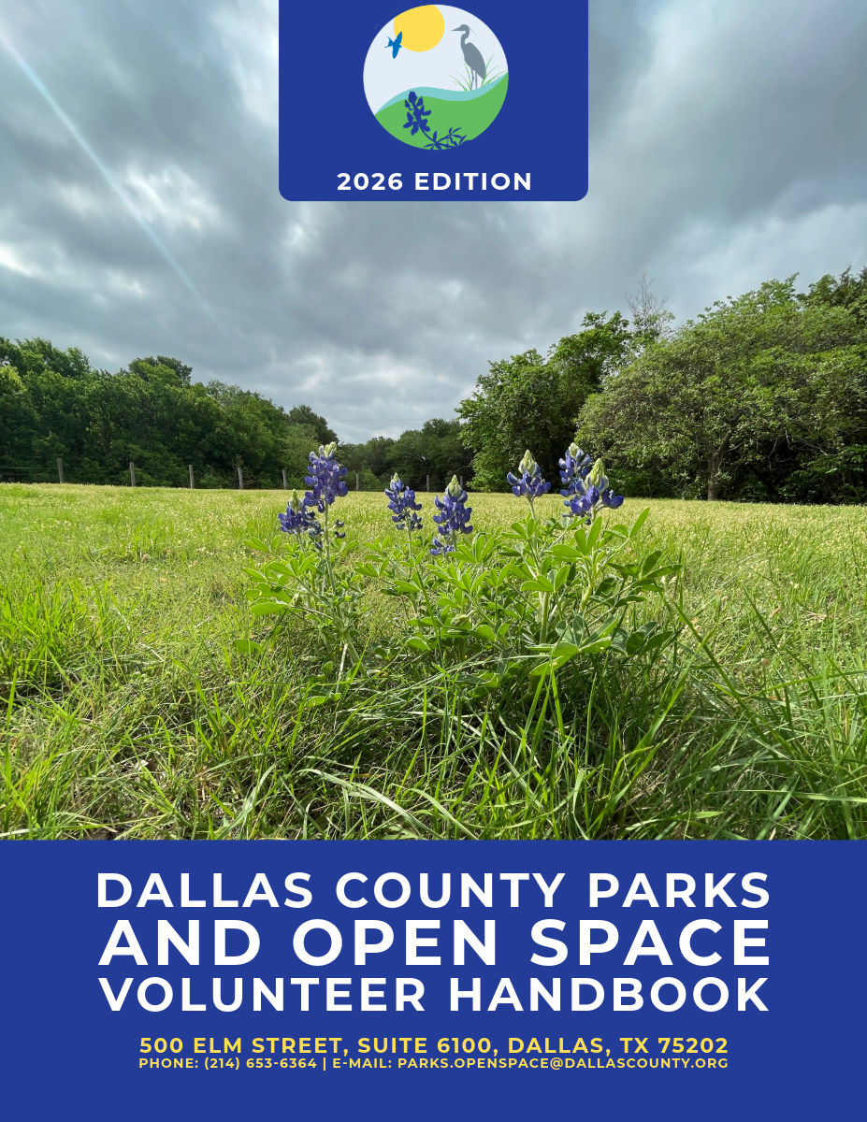

Table of Contents

- Introduction
- Policy
- Purpose
- Definitions
- Dallas County Parks and Open Space Program Mission and Goals
- Preserve Programs and Initiatives
- Volunteer Programs and Requirements
- Volunteer Program Eligibility
- Volunteer Program Application Process
- Dress Code
- Drugs and Alcohol
- Social Media Policy
- Volunteers as Minors
14. Disciplinary Policy
15. Resolution of Disciplinary Action

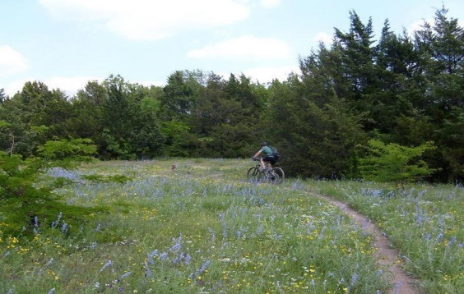
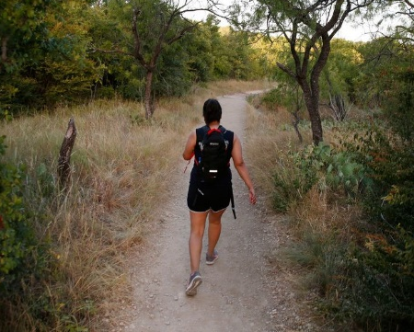
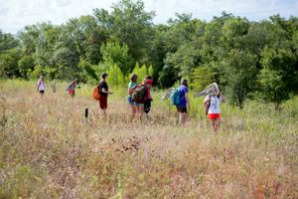
Introduction
Recognizing that the rapid urbanization of North Central Texas was significantly reducing the area's supply of undeveloped land and threatening some of its more environmentally unique features, Dallas County first began establishing an open space system in 1976.
This system now contains twenty-one preserves and 4,116 acres located throughout the County. Designed to resemble a national park rather than a neighborhood playground or athletic field, the County's preserves offer a variety of topographical, geological, and environmental experiences. Some are hilly and rocky, some are broad meadows, some include wetlands, some are heavily wooded, and some are historically significant to both Texas and Dallas County. The preserves set aside natural habitats where native plants, reptiles, birds, and mammals can continue to thrive.

The preservation of natural open spaces has many benefits: wildlife habitat, recreation opportunities, buffer zones between developments, increased property values of adjacent land, noise attenuation, air pollution reduction, water quality preservation and improvement, and natural and cultural resource preservation. The creation of the Dallas County Open Space Volunteer program is designed to support the goals and initiatives of the Dallas County Open Space program.

Policy
It is the policy of the Dallas County Parks and Open Space Program to provide a volunteer program that effectively recruits, trains, manages, retains, and recognizes the efforts of volunteers in the support of the existing 21 preserves found in Dallas County.

These policies do not constitute, either implicitly or explicitly, a binding contractual or personnel agreement. Dallas County reserves the right to change any of these policies at any time without notice and to expect adherence to any changed policy.

Purpose
The purpose of this plan is to establish guidelines and regulations for the Dallas County Parks and Open Space Volunteer Program. These volunteer policies have been developed in conjunction with Dallas County policies.

The Dallas County Parks and Open Space volunteer program provides an avenue for Dallas County community members to contribute their skills and time to a variety of needs and projects throughout the program.

It is our goal to actively promote a beneficial relationship between volunteers and staff that results in staff, volunteers and volunteer organizations working cooperatively to foster the stewardship of Dallas County’s preserves. Through these policies, we will intentionally offer volunteer opportunities to provide a structured, welcoming, and safe environment for our staff and volunteers.

Definitions
Volunteers (which do not include any individual that is requested to provide community service under some type of court or criminal justice proceeding), but do include individuals working independently or as a member of a group, school, business, or organization that perform services on county park and open space property without receiving any compensation or any other item or thing of value in lieu of compensation, may be used to improve and enhance the county’s park and open space properties when appropriate (Adopted from County Code Sec 50-261).

A “volunteer” must be officially registered and be approved by the Open Space Coordinator prior to volunteering at any Dallas County sponsored event. Once approved, a volunteer may provide service at any Open Space program event. Volunteers shall not be considered as “employees” of Dallas County.

Preserve Programs
The services that a volunteer may provide under this division include, but are not limited to, maintaining trails, removing trash and debris, mowing, installing signs, conducting special studies and inventories, taking photographs, and producing maps, brochures, or other educational materials (Adapted from County Code Sec. 50-261). Preserve projects will vary based on need and agreement with local cities.

Projects may include trash and litter removal, invasive species management, interpretive/trail signage implementation and other additional improvements.

Volunteer Policies
It is the hope of the Dallas County Parks and Open Space Program that volunteers reflect the County and the communities that they serve. In line with County commitments, the Dallas County Parks and Open Space Program will not discharge or refuse an individual, or otherwise discriminate against an individual because of the individual’s race, color, age, religion, sex, marital status, sexual orientation, national origin, disability, political opinions, or affiliations.

Volunteers are expected to:
- Be approachable, friendly, respectful, and courteous when interacting with employees, volunteers, and guests of the preserves.
- Support the mission, vision, and goals of the Dallas County Open Space Program.
- Fulfill shift obligations and be on time.
- Ensure the care and safety of all facilities, equipment, and materials while participating in various projects.
- Notify the Open Space Coordinator if they are unable to meet their commitment or will be late.
- Dress appropriately for each project.
- Keep track of their volunteer hours. Volunteers must sign-in and sign-out at volunteer events.
- Communicate any problems or concerns to the Open Space Coordinator.

Volunteers will not:
- Participate in any conduct that may endanger the safety or well-being of any volunteer, staff, preserve guest, or wildlife.
- Be under the influence or in the possession of alcohol, illegal drugs, or other intoxicants while volunteering with the Dallas County Parks and Open Space Program.
- Engage in any type of harassment including, but not limited to, insulting, degrading, or exploitive actions, words, or treatment based on gender, race, ethnicity, age, religion, or any other characteristic will not be tolerated. Crude or inappropriate jokes, or demeaning comments or attitude will not be tolerated.
- Be left in charge of a facility, handle money, or have access to facility keys. This does not prohibit volunteers from assisting in the supervision of a project including other volunteers if such volunteer has the experience or skill necessary to do so and such placement has previously been discussed with the Open Space Coordinator.
- Leave their minor children or wards alone with any one adult. There must be at least two adults visible and present when with a minor.
- Operate Dallas County vehicles, vans, trucks, or other motorized equipment.
- Ride in Dallas County vehicles.

Volunteer Eligibility
- Must be 18 or older. Minors between the ages of 13-17 can volunteer with an adult/guardian present.
- Submit a volunteer application.
- Volunteers must be free of the following convictions:
  - Murder (including capital murder)
  - Indecency with a child/child abuse/child pornography
  - Aggravated offenses
  - Sexual assault
  - Arson
  - Theft/Robbery
  - Open Warrants
  - Terroristic activity
  - Possession of explosive devices
  - Stalking
  - Burglary
  - Cruelty to animals
  - Commission of a felony offense with a deadly weapon
  - Use of a child in the commission of a felony offense
  - Injury to a child, elderly, individual, or disabled person
  - Any drug related felony offense in the last ten years

- If a volunteer application has been denied, the applicant will be notified in writing. Denied applicants can appeal the decision to the Commissioners Court if they submit a written request for an appeal to the Commissioners Court Administrator within 10 days of being informed of the Open Space Coordinator’s decision to not approve their application.

Volunteer Program Application Process
- Any interested volunteer or group will apply online through the Dallas County Parks and Open Space Program volunteer management portal. Any questions about the process can be brought to the Open Spaces Coordinator.
  - Individual members that are part of a group need to apply individually.
  - Minors (children ages 13-17) and their parents and/or guardian will need to apply separately.
- In order to have enough time to process applications, applicants must be approved at least one week prior to volunteering at any event.
- Volunteers are required to fill out a volunteer waiver. Minors’ waivers must be signed by a parent or guardian.
- We strongly encourage volunteers to sign-up online; hard copies of the application and waiver must be filled out on site if they are not completed beforehand.
Once a volunteer completes the application and waiver, the Open Space Coordinator will follow up with more information regarding whether their application is approved or denied.

Dress Code
Due to the nature of our volunteer events with the Dallas County Parks and Open Space Program, we ask that volunteers come comfortably dressed for the elements, including various weather patterns, long brush, snakes, potentially biting or stinging insects, and walking long distances over uneven terrain.

Volunteers may get dirty and may be in forested areas, as well as areas that are frequented by members of the public. Volunteers are required to wear close-toed shoes while volunteering. The Open Space Coordinator will communicate any specific needs prior to the volunteer event. Volunteers that are not dressed in accordance with policy may be turned away by Open Space staff.

Suggested List of What to Bring/Wear:
- Hat
- Water Bottle
- Close-toed shoes/Boots (Required)
- Pants
- Long-sleeve shirt (depending on area of event)
- Sunblock
- Bug spray
- Snacks/lunch (depending on length of event)
- Gloves (Gloves will also be provided by Dallas County)

Drugs and Alcohol___________________________________________________
Volunteers may not volunteer while under the influence of alcohol or any controlled substance. The unlawful manufacture, distribution, dispensation, possession, or sale, of a controlled substance at volunteer events or while on Dallas County property or at Open Space Program volunteer events is prohibited.

Alcohol is also prohibited at volunteer events.

If any volunteer is convicted of a charge involving a controlled substance (even off-grounds on their own time) they must notify the Open Space Coordinator. Failure to adhere to this policy could result in immediate termination of your volunteer assignment.

News/Social Media
Dallas County works with various departments to manage and release accurate and pertinent information to media. Volunteers are not and shall not represent themselves as spokespersons for or agents of the county. We ask that you forward any requests for interviews and articles to the Open Space Coordinator for further review. If a member of the media approaches you during a volunteer event, you are welcome to talk about your experience as a volunteer or you may direct inquiries to an official Dallas County staff member.

We hope that you enjoy your time as a volunteer and that you help us spread the word about the Dallas County Parks & Open Space Program. However, we ask that you refrain from engaging in online debates or arguments on behalf of the program. If you see an issue on social media concerning the Dallas County Parks and Open Space program, please contact our staff.
Photos and Videos may be taken by staff at the events. By attending the event you agree to any videos or pictures taken of you at the event to be used in social media content. If you are not comfortable with this, please reach out to a staff member at the beginning of the event.

Volunteers as Minors
We consider anybody under the age of 18 to be a minor (child), including other volunteers. We allow minors, ages 13-17 to volunteer under the supervision of an adult at all times.

- Volunteers are in an authoritative position to be a positive role model for children. As adults, we ask that you hold yourself to a standard of respect, patience, maturity, and tact while potentially working with minors.

- A volunteer may not be alone with a child in an area not observed by other staff or alone with someone that is not their designated parent and/or guardian.

- Physical contact with minors is reserved for when it is deemed an emergency situation.

Disciplinary Action
The Dallas County Parks and Open Space program has established standards of performance necessary for the effective implementation of volunteer events, along with the safety and well-being of staff and volunteers. While Dallas County Parks and Open Space staff may work towards a solution when problems do arise, volunteers may be faced with immediate dismissal based on facts and the severity of circumstances.

Staff Contact Information_________________________________
Dallas County Parks and Open Space Coordinator
Henry Heller – henry.heller@dallascounty.org – 214-653-6364

Dallas County Parks and Open Space Administrator
Mia Whitham – mia.whitham@dallascounty.org – 214-653-6653

